MRS. VAN SCHAICK(SKOIK) & MRS. BOLOGNA 2018-2019
GEOMETRY LAB INTEGRATED ROOM 238
Welcome to the high school! We hope you had a great summer and are now ready to work hard at Geometry this year! GOOD LUCK!!
About this course:
This course is designed to have you critically think. You will learn a lot of vocabulary, constructions, and proofs (amongst some other topics). You need to put forth effort in order to receive the best results. All quizzes and tests will reflect the level of difficulty that you will see on the New York State Regents Exam at the end of this school year.
Assessments:
Counts as 90% of your entire marking period average.
Please make up any missed assessments IMMEDIATELY!
Homework:
Counts as 10% of your entire marking period average.
Will be given nearly every night.
You must attempt the problems in order to receive credit for it.
Late homework is UNACCEPTABLE!!
Materials:
Loose-leaf Binder (large) and 13 dividers with tabs
Textbook – Geometry Big Ideas
TI-84 Plus Calculator (can be loaned out from the school store for the year)
Pens, Pencils (mechanical is best)
Big Eraser
Graph Paper
Index Cards
COMPASS
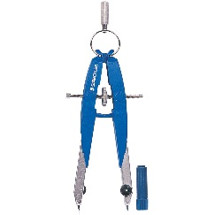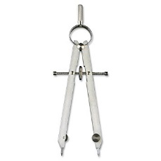
We hope you enjoy this class as much as we enjoy teaching it. Please have your parents/guardians sign below. This will count as your first homework assignment.

_________________________________________________________________________

Good luck this year!

Mrs. Van Schaick
Mrs. Bologna

Parents: Please sign the space above and also complete and return the information on the following page.

Student Name: ______________________________________________________________

Parents/Guardians: Please provide us with all of your email addresses and phone numbers, so we can have open communication throughout the year.
Mother/Guardian:
Email: ______________________________________________________________________
Phone number (home): ____________________________________________________________________________
Phone number (cell): ____________________________________________________________________________
Phone number (work): ____________________________________________________________________________

Father/Guardian:
Email: ______________________________________________________________________
Phone number (home): ____________________________________________________________________________
Phone number (cell): ____________________________________________________________________________
Phone number (work): ____________________________________________________________________________

Food Allergies: ____________________________________________________________________________________

Any comments or concerns:

____________________________________________________________________________________

____________________________________________________________________________________

____________________________________________________________________________________

